Application Building

RUN THE APP

Date 19 Nov 2022

TeamID PNT2022TMID31222

ProjectName Classification of Arrhythmia by Using

Deep Learning with 2-D ECG Spectral Image Representation

TASK:

***Run The App.***

RUN ON LOCAL HOST (SCREEN SHOT):

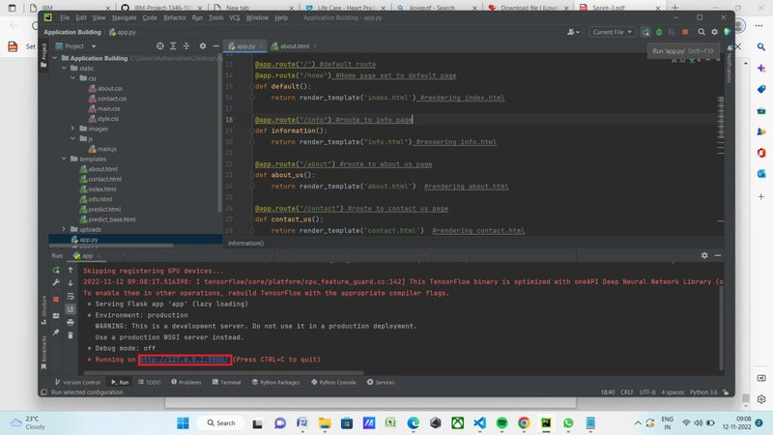

LOCAL HOST:

CLICK PREDICT (SCREEN SHOT)::

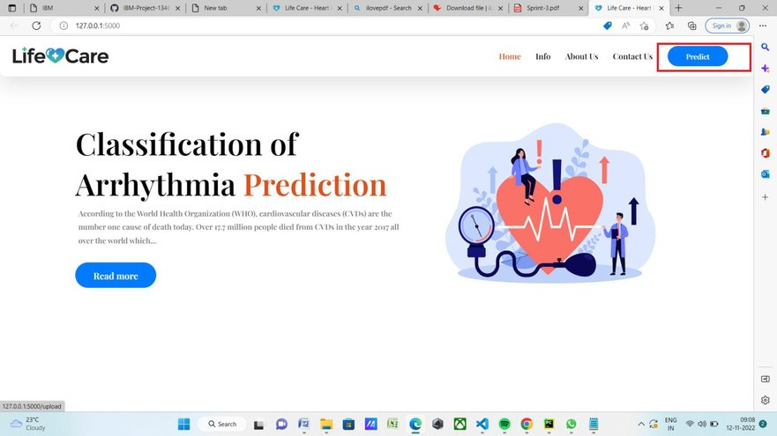

CLICK CHOOSE BUTTON (SCREEN SHOT):

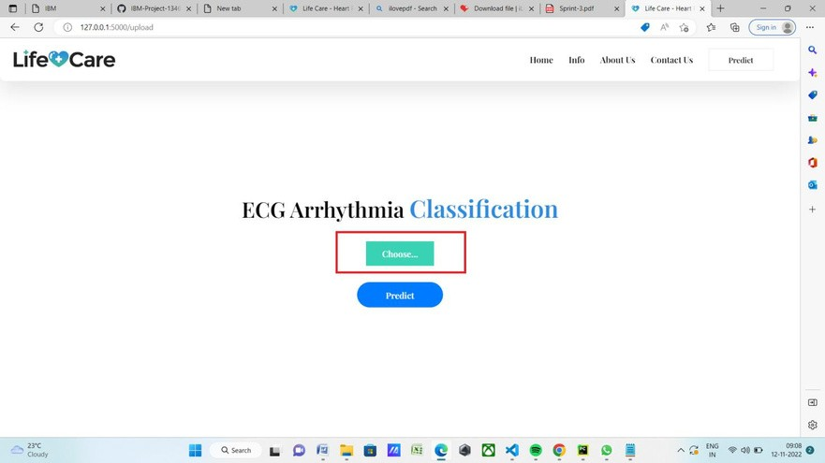

GO TO UNKNOWN FILE (SCREEN SHOT):

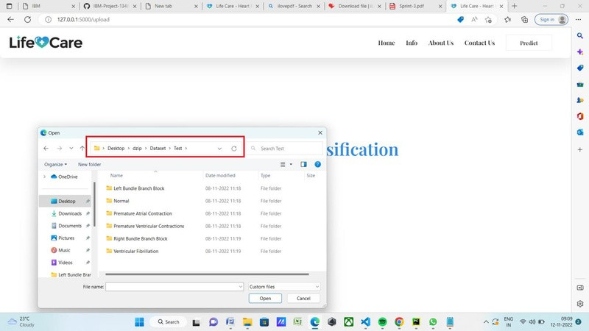SELECT ANY FILE (SCREEN SHOT):

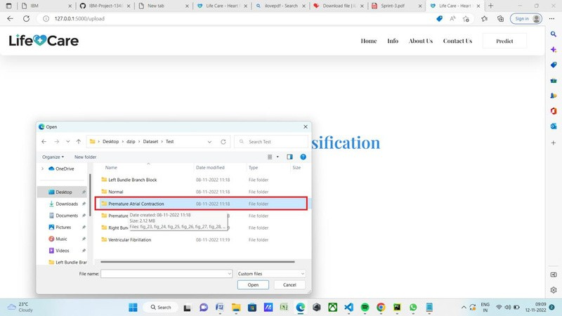

CLICK ANY ECG PHOTO (SCREEN SHOT):

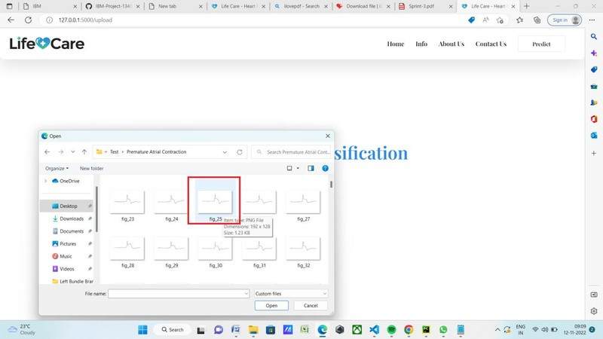CLICK PREDICT BUTTON (SCREEN SHOT):

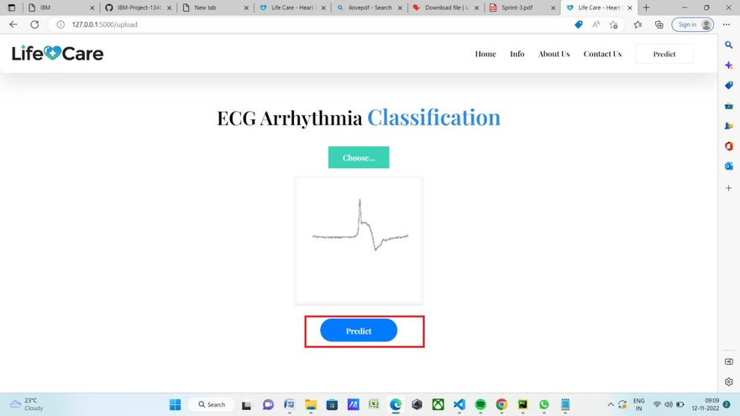

SHOW ON RESULT (SCREEN SHOT):

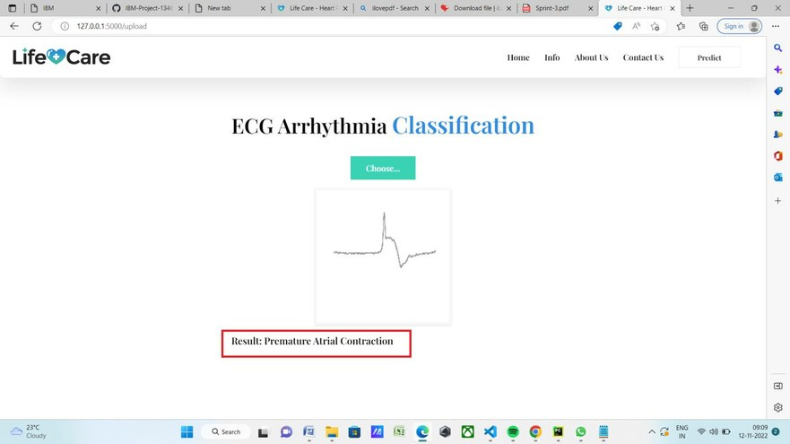PREDICT THE CORRECT RESULT